Aim: Building a school billing system using C language

Abstract

Project name: School Billing System

A school billing system is built in C language having case information of 50 students pertaining to their tuition and transport fee payment besides other personal details. The program acts as a payment gateway for the fore mentioned dues and displays the receipt at the end of the transaction.

**Model Receipt**

SRM SCHOOL

Enter the registration number:000001

SRM SCHOOL

Registration number: 000001

Name of the student: ABC

Guardian’s name : DEF

Grade : 6

Total tuition fee : 40,000/-

Scholarship (%) : 25

Net tuition fee : 30,000/-

Balance tuition fee : 10,000/-

Transport fee : 7,000/-

Balance transport fee: 4,000/-

Amount paid towards tuition fee : 6,000

Amount paid towards transport fee : 1,000

SRM SCHOOL

FEE RECIEPT

DATE: 20-11-2020

TIME: 11:50:01

Registration number: 000001

Name of the student: ABC

Guardian’s name : DEF

Grade : 6

Tuition fee paid : 6,000/-

Balance : 4,000/-

SRM SCHOOL

FEE RECIEPT

DATE: 20-11-2020

TIME: 11:50:01

Registration number: 000001

Name of the student: ABC

Guardian’s name : DEF

Grade : 6

Transport fee paid : 1,000/-

Balance : 3,000/-

ALGORITHM

1. Start
2. Display “SRM SCHOOL”
3. Declare variables regno, name, gname, grade, tutfee, scholar, netfee , transfee, tutpay, transpay, temp, transbal, tutbal,temp1
4. Read regno and display the related info using switch case.
5. If invalid regno, then display “enter valid registration number” and go to step 4.
6. netfee= tutfee- (scholar/100)*tutfee
7. Read tutpay and transpay
8. Check if tutpay<=tutbal and tutpay!= 0, if no, go to step 11.
9. If yes, temp = tutbal-tutpay , tutbal=temp
10. Display “TUITION FEE RECEIPT”, date, time, related info plus tutbal
11. Check if transpay<=transbal and transpay! = 0
12. If yes, temp1 =transbal- transpay, transbal=temp1
13. Display “TRANSPORT FEE RECEIPT”, date, time, related info plus transbal
14. If no, check if tutpay==0. If no, go to step 16.
15. If yes, display “enter valid amount” and go to step 7.
16. Stop

PSEUDO CODE

Print “SRM SCHOOL”

Declare integer variables grade, regno, tutfee, scholar, netfee, transfee, transpay, temp, transbal, tutbal, tutpay, temp1.

Declare character pointer variables name, gname.

Print “WELCOME!”

Label3:”ENTER REGESTRATION NUMBER:”

Input the regno

Print entered regno

Switch regno

Case 2101001

Assign name = ”Priyanka Srinivasan”

Assign gname = ”Sirish Srinivasan”

Assign grade = 1

Assign tutfee = 10000

Assign scholar = 5

Assign transfee = 7000

Assign tutbal = 6000

Assign transbal = 4000

Break

Keep switching cases until the case regno is equal to input regno

Switch to default case if no case regno is matched with input regno

Default

Print “Enter Valid registration number.”

Goto Label3;

Break

Print NAME OF THE STUDENT:

For loop counter temp = 0 to ‘/0’ , increment loop counter temp by 1

Print name

Print GUARDIAN’S NAME :

For loop counter temp = 0 to ‘/0’ , increment loop counter temp by 1

Print gname

Print GRADE: grade

Print TOTAL TUITION FEE: tutfee

Print SCHOLARSHIP: scholar

Print NET TUITION FEE: tutfee-tutfee*scholar/100

Print BALANCE TUITION FEE: tutbal

Print TRANSPORT FEE: transfee

Print BALANCE TRANSPORT FEE: transbal

Label1: Print Amount paid towards tuition fee:

Input tutpay

Label2: Print Amount paid towards transport fee:

Input transpay

If tutpay <= tutbal and tutpay != 0

temp1 = tutbal-tutpay

tutbal = temp1

Declaring Time variable time_t tm

Storing current time and date in time variable tm

Print “SRM SCHOOL”

Print FEE RECEIPT

Print DATE & TIME: ctime(&tm)

Print REGISTRATION NUMBER: regno

Print NAME OF THE STUDENT:

For loop counter temp = 0 to ‘/0’ , increment loop counter temp by 1

Print name

Print GUARDIAN’S NAME :

For loop counter temp = 0 to ‘/0’ , increment loop counter temp by 1

Print gname

Print GRADE: grade

Print TUITION FEE PAID: tutpay

Print BALANCE: tutbal

Else if tutpay > tutbal

Print “Amount paid exceeds balance tuition fee”

Goto label1

If transpay <= transbal and transpay !=0

temp1 = transbal-transpay

transbal = temp1

Storing current time and date in time variable tm

Print “SRM SCHOOL”

Print FEE RECEIPT

Print DATE & TIME: ctime(&tm)

Print REGISTRATION NUMBER: regno

Print NAME OF THE STUDENT:

For loop counter temp = 0 to ‘/0’ , increment loop counter temp by 1

Print name

Print GUARDIAN’S NAME :

For loop counter temp = 0 to ‘/0’ , increment loop counter temp by 1

Print gname

Print GRADE: grade

Print TRANSPORT FEE PAID: transpay

Print BALANCE: transbal

Else if transpay > transbal

Print “Amount paid exceeds balance transport fee”

Goto label2

Else if transpay==0

Goto label

Else

Print “Enter valid amount”

Goto label1

Label(End)

CODE

#include<stdio.h>

#include<string.h>

#include<time.h>

int main(){

printf("\t\t\t\t\tSRM SCHOOL\n");

int grade,regno,tutfee,scholar,netfee,transfee,transpay,temp,transbal,tutbal,tutpay,temp1;

char *name,*gname;

printf("WELCOME!\n");

label3:printf("ENTER REGISTRATION NUMBER:");

scanf("%d",&regno);

printf("REGISTRATION NUMBER : %d\n",regno);

switch(regno){

case 2101001:

{name="Mahendra Bahubali";

gname="Amerendra Bahubali";

grade=1;

tutfee=10000;

scholar=5;

transfee=7000;

tutbal=6000;

transbal=4000;

break;}

case 2101002:

{name="Ballala Deva";

gname="Bhijjal Deva";

grade=1;

tutfee=10000;

scholar=0;

transfee=8000;

tutbal=5500;

transbal=4500;

break;}

case 2101003:

{name= "Avanthika Devi";

gname="Sivagami Devi";

grade=1;

tutfee=10000;

scholar=0;

transfee=8500;

tutbal=6000;

transbal=5000;

break;}

case 2101004:

{

name="Shiva Raja";

gname="Kalakeya Raja";

grade=1;

tutfee=10000;

scholar=0;

transfee=9000;

tutbal=6500;

transbal=5000;

break;}

case 2102001:

{name="Vijay Chaudhari";

gname="Sunita Choudhari";

grade=2;

tutfee=20000;

scholar=5;

transfee=8500;

tutbal=6500;

transbal=5000;

break;}

case 2102002:

{name="Naga Chaitanya Akkineni";

gname="Nagarjuna Akkineni";

grade=3;

tutfee=30000;

scholar=0;

transfee=7500;

tutbal=9000;

transbal=4000;

break;}

case 2102003:

{name="Arjun Singh";

gname="Kabeer Das";

grade=2;

tutfee=20000;

scholar=0;

transfee=8000;

tutbal=6000;

transbal=5000;

break;}

case 2102004:

{name="Sreeja Kalyan";

gname="Chiranjeevi Shetty";

grade=2;

tutfee=20000;

scholar=0;

transfee=7500;

tutbal=5500;

transbal=5000;

break;}

case 2103001:

{name="Karthika Sharma";

gname="Radha Sharma";

grade=3;

tutfee=30000;

scholar=0;

transfee=7500;

tutbal=18000;

transbal=4000;

break;}

case 2103002:

{name="Shruti Hassan";

gname="Kamal Hassan";

grade=3;

tutfee=30000;

scholar=0;

transfee=9500;

tutbal=16000;

transbal=6000;

break;}

case 2103003:

{name="Siddharth Roy";

gname="Charishma Varma";

grade=3;

tutfee=30000;

scholar=5;

transfee=8500;

tutbal=16500;

transbal=3500;

break;}

case 2103004:

{name="Dhanush Vasa";

gname="Ramesh Vasa";

grade=3;

tutfee=30000;

scholar=0;

transfee=8000;

tutbal=17000;

transbal=4500;

break;}

case 2104001:

{name="Shaik Haseena";

gname="Shaik Khadar Basha";

grade=4;

tutfee=40000;

scholar=10;

transfee=10000;

tutbal=25000;

transbal=7000;

break;}

case 2104002:

{name="Gaddam Yacob";

gname="Gaddam Mariya";

grade=4;

tutfee=40000;

scholar=0;

transfee=7500;

tutbal=20000;

transbal=6000;

break;

}

case 2104003:

{name="Chaluvadi Seetha Mahalakshmi";

gname="Yarramasu Ramayya";

grade=4;

tutfee=40000;

scholar=0;

transfee=15000;

tutbal=30000;

transbal=8000;

break;

}

case 2104004:

{name="Moram Nikhil";

gname="Moram Joseph";

grade=4;

tutfee=40000;

scholar=0;

transfee=7000;

tutbal=0;

transbal=1000;

break;

}

case 2105001:

{name="Mundru Sathvika";

gname="Mundru Jaydev";

grade=5;

tutfee=50000;

scholar=0;

transfee=11000;

tutbal=30000;

transbal=10000;

break;

}

case 2105002:

{name="Kolluru Abhishek";

gname="Narravula Ramarao";

grade=5;

tutfee=50000;

scholar=10;

transfee=10000;

tutbal=50000;

transbal=7000;

break;

}

case 2105003:

{

name="Shaik Samad";

gname="Shaik Saad";

grade=5;

tutfee=50000;

scholar=0;

transfee=8000;

tutbal=1000;

transbal=0;

break;

}

case 2105004:

{name="Dammati Sai Supriya";

gname="Dammati Anupama";

grade=5;

tutfee=50000;

scholar=0;

transfee=10000;

transbal=5000;

tutbal=45000;

break;

}

case 2106001:

{name="Shaik Faizuddin";

gname="Shaik Saad";

grade=6;

tutfee=60000;

scholar=0;

transfee=8000 ;

tutbal=2000;

transbal=1000;

break;

}

case 2106002:

{name="Kaviti Sreeja";

gname="Kaviti Sreedhar";

grade=6;

tutfee=60000;

scholar=0;

transfee=12000;

tutbal=35000;

transbal=7000;

break;

}

case 2106003:

{name="Maramreddy Vikas Narayana";

gname="Maramreddy Venkat Reddy";

grade=6;

scholar=0;

transfee=14000;

tutfee=60000;

tutbal=40000;

transbal=7000;

break;

}

case 2106004:

{name="Sangam Daniel";

gname="Sangam Sudhakar";

grade=6;

scholar=10;

tutfee=60000;

transfee=15000;

tutbal=40000;

transbal=7500;

break;

}

case 2107001:

{name="Veer Goyal";

gname="Sanjay Goyal";

grade=7;

tutfee=70000;

scholar=20;

transfee=9000;

tutbal=60000;

transbal=5000;

break;}

case 2107002:

{name="Kushal Singhi";

gname="Seema Singhi";

grade=7;

tutfee=70000;

scholar=0;

transfee=8000;

tutbal=70000;

transbal=4000;

break;}

case 2107003:

{name="Shweta Parashar";

gname="Akash Parashar";

grade=7;

tutfee=70000;

scholar=0;

transfee=11000;

tutbal=60000;

transbal=6000;

break;}

case 2107004:

{name="Kritika Jain";

gname="Vijay Goyal";

grade=7;

tutfee=70000;

scholar=0;

transfee=12000;

tutbal=80000;

transbal=7000;

break;}

case 2108001:

{name="Shreyansh Gupta";

gname="Prakhar Gupta";

grade=8;

tutfee=80000;

scholar=0;

transfee=9000;

tutbal=60000;

transbal=5000;

break;}

case 2108002:

{name="Simran Agrawal";

gname="Ajay Agrawal";

grade=8;

tutfee=80000;

scholar=20;

transfee=10000;

tutbal=70000;

transbal=7000;

break;}

case 2108003:

{name="Lakshya Mehra";

gname="Vibha Mehra";

grade=8;

tutfee=80000;

scholar=0;

transfee=11000;

tutbal=80000;

transbal=7000;

break;}

case 2108004:

{name="Mansi Mundra";

gname="Abhishek Mundra";

grade=8;

tutfee=80000;

scholar=0;

transfee=9000;

tutbal=60000;

transbal=5000;

break;}

case 2109001:

{name="Neha Jain";

gname="Pavan Jain";

grade=9;

tutfee=90000;

scholar=0;

transfee=10000;

tutbal=70000;

transbal=5000;

break;}

case 2109002:

{name="Nandini Rathi\n";

gname="Shilpa Rathi";

grade=9;

tutfee=90000;

scholar=20;

transfee=11000;

tutbal=60000;

transbal=7000;

break;}

case 2109003:

{name="Anna Mathews";

gname="David Mathews";

grade=9;

tutfee=90000;

scholar=0;

transfee=9000;

tutbal=70000;

transbal=5000;

break;}

case 2109004:

{name="Harsh Agrawal";

gname="Vikas Agrawal";

grade=9;

tutfee=90000;

scholar=0;

transfee=9000;

tutbal=80000;

transbal=5000;

break;}

case 2110001 :

{name= "Draco Malfoy";

gname= "Narcissa Malfoy";

grade=10;

tutfee=100000;

scholar=0;

transfee=12000;

tutbal=90000;

transbal=10000;

break;}

case 2110002 :

{name=" Hermione Granger";

gname="Stevie Granger";

grade=10;

tutfee=100000;

scholar=50;

transfee=15000;

tutbal=75000;

transbal=5000;

break;}

case 2110003 :

{name= "Harry Potter";

gname= "Sirius Black";

grade=10;

tutfee=100000;

scholar=0;

transfee=7500;

tutbal=85600;

transbal=7500;

break;}

case 2110004 :

{name= "Ron Weasley";

gname=" Arthur Weasley";

grade=10;

tutfee=100000;

scholar=0;

transfee=13500;

tutbal=86000;

transbal=5000;

break;}

case 2111001 :

{name= "Luna Lovegood";

gname="Xenophilius Lovegood";

grade=11;

tutfee=110000;

scholar=0;

transfee=8600;

tutbal=85000;

transbal=8000;

break;}

case 2111002 :

{name="Ginny Weasley";

gname="Molly Weasley";

grade=11;

tutfee=110000;

scholar=30;

transfee=13500;

tutbal=87000;

transbal=45000;

break;}

case 2111003 :

{name="Tom Riddle";

gname= "Merope Riddle";

grade=11;

tutfee=110000;

scholar=0;

transfee=15000;

tutbal=66000;

transbal=800;

break;}

case 2111004 :

{name= "Cho Chang";

gname= "Robin Chang";

grade=11;

tutfee=110000;

scholar=0;

transfee=6000;

tutbal=90000;

transbal=4500;

break;}

case 2112001 :

{name= "George Weasley";

gname = "Molly Weasley";

grade=12;

tutfee=120000;

scholar=0;

transfee=13500;

tutbal=89000;

transbal=9000;

break;}

case 2112002 :

{name= "Fred Weasley";

gname = "Molly Weasley";

grade=12;

tutfee=120000;

scholar=0;

transfee=13500;

tutbal=89000;

transbal=9000;

break;}

case 2112003 :

{name= "Katie Bell";

gname = "Dean Bell";

grade=12;

tutfee=120000;

scholar=50;

transfee=12000;

tutbal=87000;

transbal=6900;

break;}

case 2112004 :

{name = "Lavender Brown";

gname = "Miriam Brown";

grade=12;

tutfee=120000;

scholar=0;

transfee=14000;

tutbal=69000;

transbal=7000;

break;}

case 2112005 :

{name = "Mark Brown";

gname = "Elon Brown";

grade=12;

tutfee=120000;

scholar=0;

transfee=13000;

tutbal=68000;

transbal=7000;

break;}

case 2112006 :

{name = "Elon Musk";

gname = "Rose Brown";

grade=12;

tutfee=120000;

scholar=0;

transfee=14000;

tutbal=66000;

transbal=6000;

break;}

default: {

printf("Enter valid registration number.\n");

goto label3;

break;}

}

printf("NAME OF THE STUDENT : ");

for(temp=0;name[temp]!='\0';temp++){

printf("%c",name[temp]);

}

printf("\nGUARDIAN'S NAME : ");

for(temp=0;gname[temp]!='\0';temp++){

printf("%c",gname[temp]);

}

printf("\nGRADE : %d\nTOTAL TUTION FEE : %d\nSCHOLARSHIP(%%) : %d\nNET TUTION FEE : %d\nBALANCE TUTION FEE : %d\nTRANSPORT FEE : %d\nBALANCE TRANSPORT FEE : %d\n"

,grade,tutfee,scholar,tutfee-tutfee*scholar/100,tutbal,transfee,transbal);

label1: printf("Amount paid towards tution fee : \n");

scanf("%d",&tutpay);

label2: printf("Amount paid towards transport fee : ");

scanf("%d",&transpay);

if (tutpay<=tutbal&&tutpay!=0){temp1=tutbal-tutpay;

tutbal=temp1;

time_t tm;

time(&tm);

printf("\t\t\t\t\tSRM SCHOOL\n\t\t\t\t\tFEE RECEIPT\nDATE & TIME : %s\nREGISTRATION NUMBER : %d\nNAME OF THE STUDENT : ",ctime(&tm),regno);

for(temp=0;name[temp]!='\0';temp++){

printf("%c",name[temp]);

}

printf("\nGUARDIAN'S NAME : ");

for(temp=0;gname[temp]!='\0';temp++){

printf("%c",gname[temp]);

}

printf("\nGRADE : %d\nTUITION FEE PAID : %d\nBALANCE : %d\n",grade,tutpay,tutbal);}

else if(tutpay>tutbal) {

printf("Amount paid exceeds balance tuition fee.\n");

goto label1;}

if(transpay<=transbal&&transpay!=0){

temp1=transbal-transpay;

transbal=temp1;

time_t tm;

time(&tm);

printf("\t\t\t\t\tSRM SCHOOL\n\t\t\t\t\tFEE RECEIPT\nDATE & TIME : %s\nREGISTRATION NUMBER : %d\nNAME OF THE STUDENT : ",ctime(&tm),regno);

for(temp=0;name[temp]!='\0';temp++){

printf("%c",name[temp]);

}

printf("\nGUARDIAN'S NAME : ");

for(temp=0;gname[temp]!='\0';temp++){

printf("%c",gname[temp]);

}

printf("\nGRADE : %d\nTRANSPORT FEE PAID : %d\nBALANCE : %d",grade,transpay,transbal);}

else if(transpay>transbal) {

printf("Amount paid exceeds balance transport fee.\nEnter valid amount.\n");

goto label2;}

else if(transpay==0&&tutpay!=0){goto label;

}

else {

printf("Enter valid amount\n");

goto label1;}

label:

return 0;

}

OUTPUT

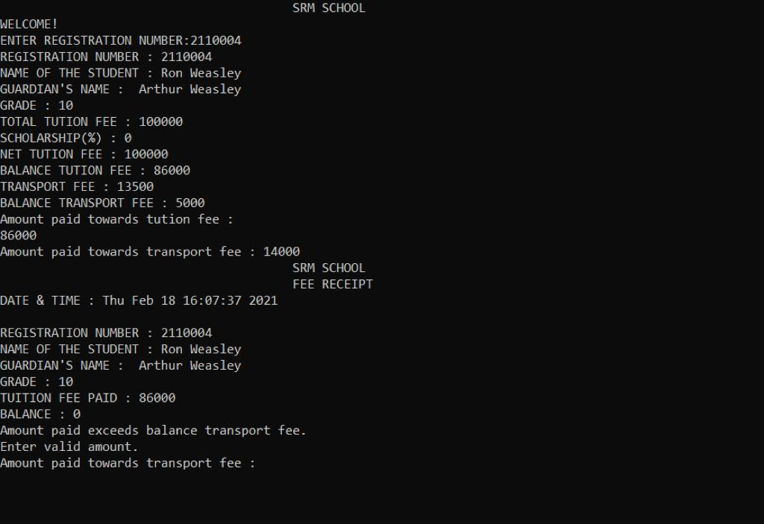

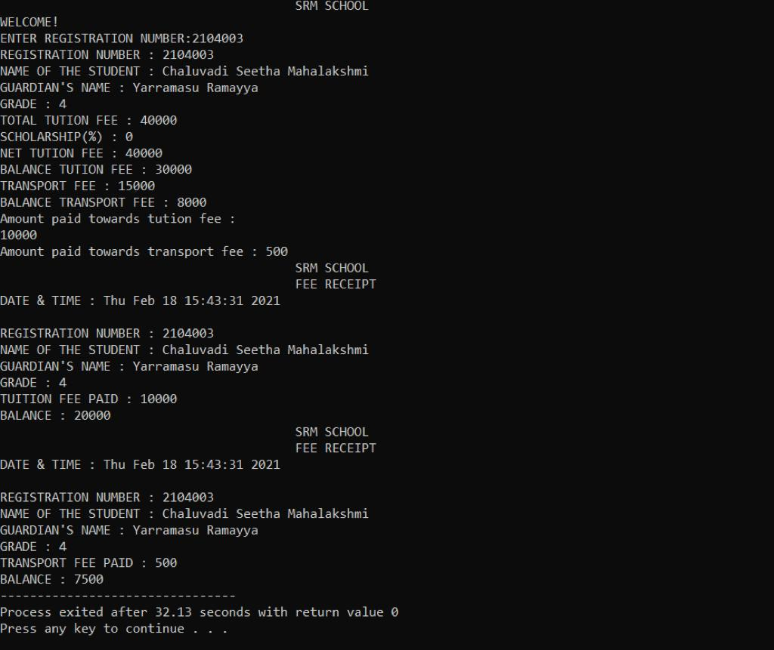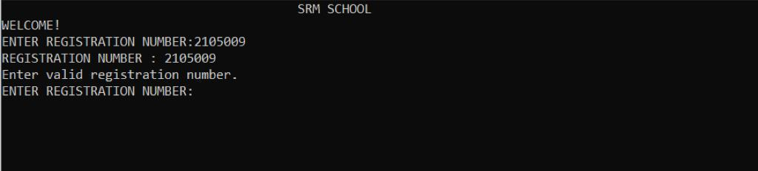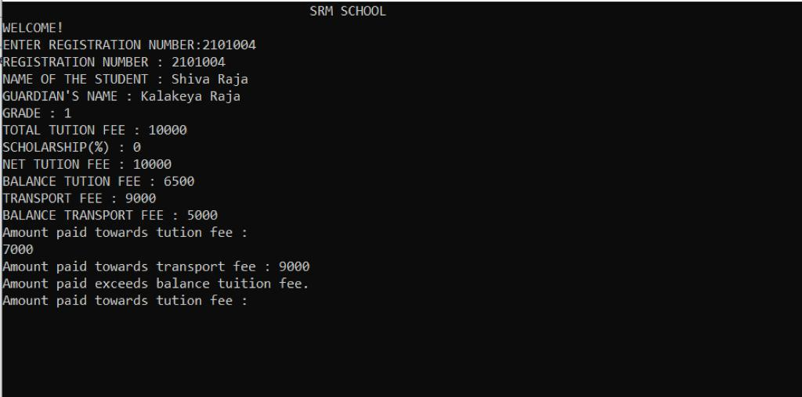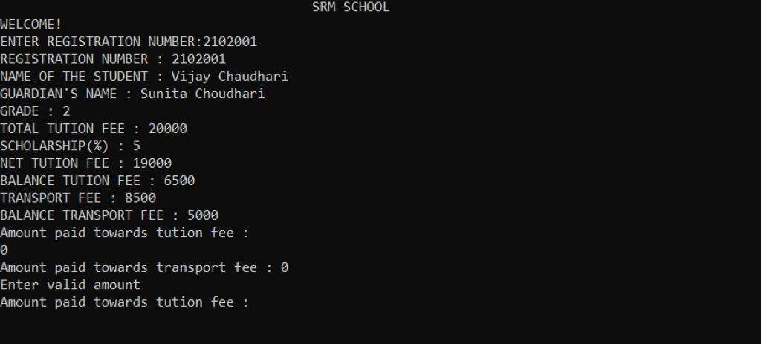

CONCLUSION

School Billing System using C language is built using simple functions and switch cases.